The proposed taxonomy is structured around two primary components:
Types of Bias (Table 1): Each category captures different sources of bias, from individual and identity-based biases (e.g., race, gender, age) to social biases (influenced by relationships and affiliations) and professional biases (related to education, career history, or career path). Additional categories include situational and contextual factors, behavioural biases, and compound biases, which arise from intersecting identities, such as race and gender. This categorisation aims to comprehensively map the diverse ways biases emerge, offering a detailed view of the factors influencing judgement and decision-making.
Bias Measurement Methods: The second section (Table 2) outlines statistical methods used to measure and quantify bias across different groups. These methods include demographic parity, equal opportunity, and adverse impact, each providing a distinct approach to assess the fairness of outcome distribution among demographic groups. For example, demographic parity evaluates whether all groups experience positive outcomes at comparable rates, while equal opportunity checks that qualified individuals from all groups have an equal chance of success.

Table I: Taxonomy of bias types (What and Where)
 | Bias Categories | Definition | Sub-categories
1 | Personal Identity Biases | Type of bias where an individual’s judgment, perception, or analysis is influenced by their own identity, personal beliefs, or individual characteristics, often subconsciously. | Race, Ethnicity, Gender, Age, Disability, Religion, Sexual Orientation, National Origin, Socioeconomic Status, Language, Political Beliefs, Marital Status, Parental Status, Appearance/ Physical Appearance (e.g., grooming, style), ,Body Size, Education, Veteran Status, Criminal History, Genetic Information, Cultural Background, Geographical Location, Work Experience, Professional Title, Legal Status (e.g., citizenship, residency), Mental Health Status, Body Modification (e.g., tattoos, piercings), Neurodiversity, Family Status (e.g., single, divorced), Personal Beliefs and Values, Height, Weight, Hair , Colour, Eye Colour, Facial Features, Body Type, Voice Accent, Speech Patterns, Handedness (e.g., left-handedness), Personal Hygiene
2 | Social and Relational Biases | Influenced by social interactions, relationships, and affiliations, affecting perceptions and judgements about others based on social connections. | Social Class, Relationship Status (e.g., in a relationship, single), Sexual Behaviour, Family Responsibilities (e.g., caregiver roles), Community Involvement, Social Networks, Peer Group, Affiliations, Friendship Circles, Marital Role Expectations, Parenting Style, Household Composition (e.g., single-parent, extended family)
3 | Professional and Educational Biases | Linked to professional roles, academic backgrounds, or educational experiences, often influencing assessments of capability or competence. | Educational Institution (e.g., alma mater prestige), Field of Study (e.g., STEM vs. humanities), Certifications and Licenses, Job Title, Industry (e.g., tech, finance, healthcare), Career Path (e.g., non-linear vs. linear), Professional Affiliations, Employment History, Job Performance Metrics, Promotional Opportunities, Work Ethic Perceptions, Leadership Style, Career , achievements, Professional Skills, Technical Proficiency
4 | Behavioural and Psychological Biases | Rooted in psychological patterns or behaviours, such as tendencies toward risk aversion, conformity, or impulsivity, impacting decision-making. | Personality Traits (e.g., introversion vs. extroversion), Behavioural Tendencies (e.g., risk-taking, caution), Emotional Intelligence, Conflict Resolution Style, Motivational Drivers  Cognitive Styles (e.g., analytical vs. creative), Stress Management, Adaptability and Flexibility, Problem-Solving Approaches, Decision-Making Styles, Work-Life Balance Preferences, Time Management Skills, Learning Styles, Feedback Reception
5 | Situational and Contextual Biases | Emerges from specific situations or contexts, where the environment or setting influences perceptions and judgements. | Power Dynamics (e.g., authority vs. subordinate), Role-Based Bias (e.g., manager vs. employee), Organizational Hierarchy, Team Dynamics, Work Environment (e.g., remote vs. in-office), Project Assignments, Resource Availability, Organizational Culture, Leadership Influence, Policy and Procedure Adherence, Crisis Situations (e.g., high-stress scenarios), Change Management, Innovation Acceptance, Risk Management Approaches, Cultural Sensitivity in Context, Situational Stressors
6 | Intersectional and Compound Biases | Arising from multiple overlapping social identities (e.g., race and gender), creating unique forms of discrimination. | Intersectional Bias (e.g., combination of race and gender), Compound Discrimination (e.g., age and disability), Multiple Identity Factors (e.g., race, gender, and socioeconomic status), Layered Discrimination (e.g., immigrant status and language proficiency), Dual Minority Status (e.g., LGBTQ+ and racial minority), Complex Identity Intersections (e.g., neurodiversity and veteran status)
7 | Technological and Media Biases | Derived from the influence of media portrayals, digital platforms, or technological systems, shaping opinions and behaviours through content exposure. | Digital Literacy, Technology Access, Social Media Presence, Online Behaviour, Digital Footprint, Media Consumption Habits, Virtual Communication Styles, Technological Proficiency, Preference for Communication Channels
8 | Health and Wellness Biases | Related to physical or mental health status, impacting assumptions and treatments of individuals based on perceived wellness. | Physical Health Status, Chronic Illness, Fitness Level, Dietary Preferences (e.g., vegetarian, vegan), Health Behaviours (e.g., smoking, alcohol consumption), Healthcare Access, Body Image Perceptions, Wellness Practices (e.g., meditation, exercise), Mental Health Treatments
9 | Cultural and Regional Biases | Shaped by cultural norms, traditions, or regional backgrounds, influencing attitudes toward different groups or practices. | Cultural Norms and Practices, Regional Dialects, Local Customs, Cultural Heritage, Traditions and Celebrations, Cultural Adaptability, Regional Stereotypes, Cultural Expression Styles, Multicultural Competence, Cultural Identity Strength, Generational Identity Bias (e.g., Gen Z, Millennial, Gen X, Baby Boomer).
10 | Additional Behavioural Bias Indicators | Specific indicators that reveal underlying behavioural biases, such as consistency in certain judgement errors or tendencies. | Rudeness or Aggressiveness, Stereotyping and Generalizations, Discriminatory Language, Microaggressions, Implicit Biases, Overgeneralizations, Exclusive Language, Favouritism, Prejudice, Assumptions Based on Appearance
11 | Contextual and Situational Bias Factors | Factors within specific contexts or situations that can lead to biased assessments or behaviours, often unique to temporary or evolving environments. | Power Dynamics (e.g., authority vs. subordinate), Role-Based Bias (e.g., manager vs. employee), Cultural Sensitivity in Context, Situational Stressors, Organizational Hierarchy, Team Dynamics, Work Environment (e.g., remote vs. in-office), Resource Availability, Organizational Culture, Leadership Influence
12 | Miscellaneous Biases | Other biases that do not fit standard categories but can still affect decision-making and interpersonal views. | Hobbies and Interests, Volunteer Work, Artistic Preferences, Fashion Sense, Travel Experience, Pet Ownership, Personal Achievements, Life Experiences, Creative Expression, Technological Adoption (e.g., early adopters vs. late adopters), Financial Literacy, Investment Behaviour, Consumer Habits, Environmental Consciousness, Sustainability Practices, Ethical Beliefs,  Philanthropic Activities, Risk Aversion, Adventure Seeking, Personal Resilience

Table II: Statistical bias measurement metrics (How to measure)
 | Measurement Method | Definition
1 | Demographic Parity (Statistical Parity) | Ensures that all demographic groups experience the same rate of positive outcomes, regardless of other attributes.
2 | Equalized Odds | Measures if a system's errors (false positives and false negatives) are evenly distributed across different demographic groups.
3 | Equal Opportunity | Focuses on equalising the true positive rate across groups, ensuring that qualified individuals from all demographics have the same likelihood of positive outcomes.
4 | Disparate Impact Ratio | Compares the rate of positive outcomes for minority groups to that for majority groups, often using the "four-fifths rule" to detect potential bias.
5 | Accuracy and Error Rates by Group | Measures the proportion of correct and incorrect outcomes for different demographic groups, revealing disparities in system performance.
6 | Calibration (Predictive Parity) | Ensures predicted probabilities align with actual outcomes across groups, maintaining accuracy in probability predictions for all demographics.
7 | Treatment Parity (Group Fairness) | Evaluates whether individuals from different groups receive similar treatment in the decision-making process, regardless of outcome differences.
8 | Conditional Demographic Disparity (CDD) | Measures demographic disparity after adjusting for relevant, non-discriminatory factors like qualifications.
9 | Adverse Impact (AI) | Assesses if policies or practices lead to disproportionate effects on protected groups, often using legal frameworks for evaluation.

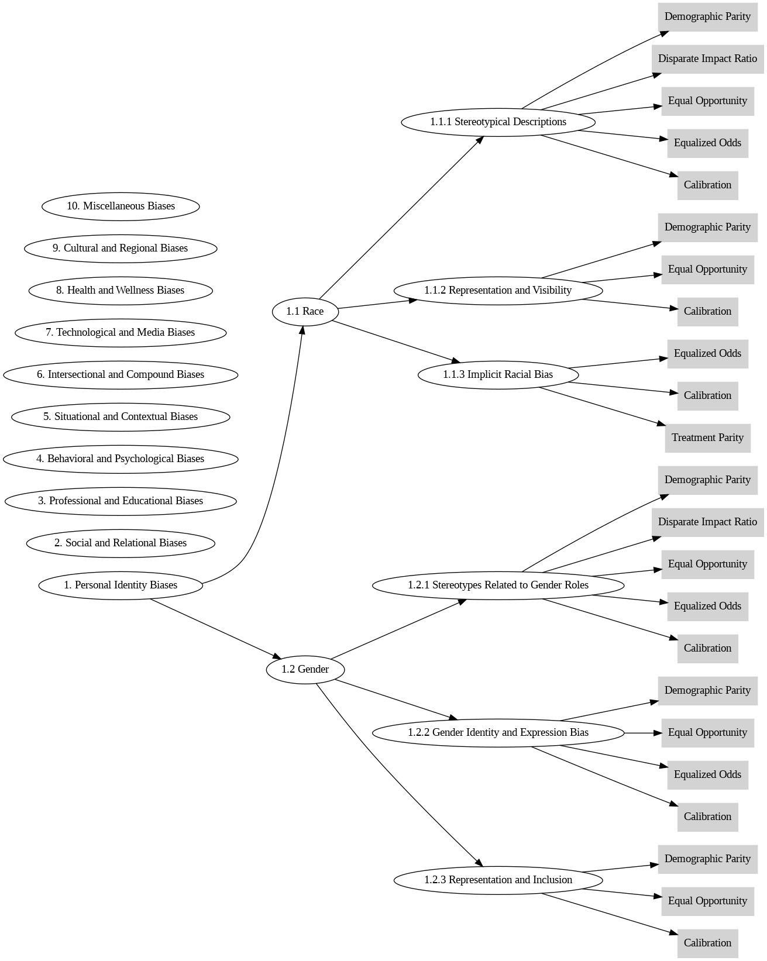
Figure 1: An example of overall taxonomy that how different types of Bias are linked with different methods to quantify the bias

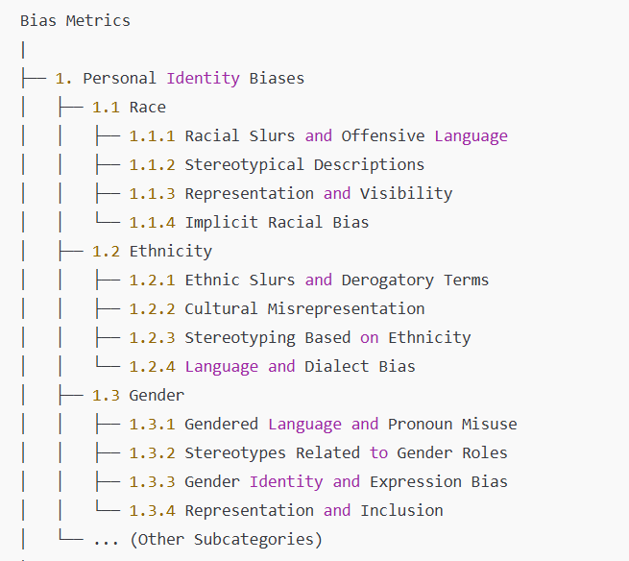

References:
- Equal Employment Opportunity Commission (EEOC): EEOC Protected Classes
- Americans with Disabilities Act (ADA): ADA Standards
- Global Diversity & Inclusion Benchmarks (GDIB): GDIB Standards
- UNESCO’s EDI Guidelines: UNESCO Inclusion
- SRI International’s Fairness, Accountability, and Transparency in Machine Learning: SRI FAIR ML
- World Economic Forum’s Diversity and Inclusion Framework: WEF D&I
- Human Rights Campaign (HRC) Diversity Best Practices: HRC Best Practices

